**Kol Simcha Torah Gazette**

**For parsha va’eschanan 5785**

Volume 9 Issue 45 (Whole #459) 15 Menachem Av 5785/ August 9, 2025

**Printed L’illuy nishmas Nechama bas R’ Noach, a”h**

For a free subscription, please forward your request to [***keren18@juno.com***](mailto:keren18@juno.com)

***Past emails can be found on the website ShabbosStories.com under Brooklyn Torah Gazette***

**Maimonides: The Reluctant Doctor Who Changed Medicine**

**By**[**Yehuda Shurpin**](https://www.chabad.org/search/keyword_cdo/kid/15169/jewish/Shurpin-Yehuda.htm)

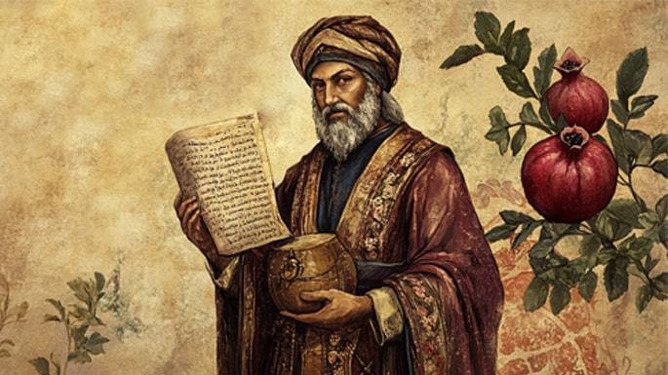

***Art by***[***Sefira Lightstone***](https://www.chabad.org/3159160)

*Rabbi Moshe ben Maimon (1138-1204), better known as Maimonides or Rambam, stands as one of history's most remarkable figures. While he's primarily celebrated for his groundbreaking works in Jewish law and philosophy, including the Mishneh Torah and Guide for the Perplexed, his role as a physician shaped much of his adult life. And yet he came to medicine through tragedy rather than by choice.*

**The Tragic Turn**

Initially, [Maimonides](https://www.chabad.org/library/article_cdo/aid/889836/jewish/Maimonides-The-Rambam.htm) devoted himself entirely to [Torah](https://www.chabad.org/library/article_cdo/aid/1426382/jewish/Torah.htm) study after his family settled in Egypt. His younger brother David supported him financially, managing the family's savings through merchant trade. However, fate took a cruel turn when David sought greater prosperity than the Sudanese port of ʿAydhab, where his family had sent him, and attempted an ambitious trading voyage to India. Tragically, he drowned at sea on his way to India between 1169 and 1177, never reaching his destination.

This loss, following soon after the death of their father, devastated Maimonides. In a letter discovered in the Cairo Geniza, he described it as the greatest tragedy of his life, leaving him bedridden for a year with illness and depression. The emotional and financial impact was severe – he now needed to support both his own family and his brother's. This crisis led Maimonides to pursue medicine as a profession.

**Rise to Prominence**

Maimonides' medical expertise quickly gained recognition. He was appointed court physician to Vizier al-Fadil, who governed Egypt while Sultan Saladin fought in the Crusades. His reputation grew so impressive that, according to legend, Richard the Lion-Hearted of England invited him to become his personal physician – an offer Maimonides declined.[1](javascript:doFootnote('1a6749811');) He later served as physician to Saladin himself and, after Saladin's death in 1193, to his son al-Afdal Nur al Din Ali.[2](javascript:doFootnote('2a6749811');)

**A Day in the Life of a Medieval Doctor**

In 1199, Maimonides wrote a remarkable letter to Rabbi Shmuel ibn Tibbon, who translated his works from Judeo-Arabic to Hebrew. In it, he paints a vivid picture of his exhausting daily routine. Ibn Tibbon wished to visit Maimonides and discuss their work. In response, Maimonides explained why such a visit may very well end in disappointment:

I live in Fostat, about a mile and a half from Cairo where the Sultan lives. My work for the Sultan is incredibly demanding. I have to visit him early every morning, and if he, his children, or any of his wives get sick, I'm stuck at the palace most of the day. Plus, I often have to treat sick palace officials. So every morning I make the trip to Cairo, and even on quiet days, I can't get back home to Fostat until the afternoon.

When I finally return home, I'm starving, but I find my waiting room packed with patients! There are Jews and non-Jews, rich and poor, officials and ordinary folks, people who like me and people who don't. They're all waiting for me to see them.

After dismounting and washing up, I beg my patients to give me a few minutes to eat something small – it's the only meal I get in 24 hours. Then I start seeing patients and writing prescriptions. This goes on until dark, and I swear on my faith, sometimes for two or three hours after sunset. I get so tired that I end up talking to patients and writing prescriptions while lying down. By nighttime, I'm so exhausted

I can barely speak.

Because of this, I can only meet with my Jewish community members on the Sabbath. That's when most of the congregation comes to see me after morning prayers, and I teach them what they need to know for the coming week. We study together until noon when they leave. Some come back after afternoon prayers and study with me until evening prayers. That's how I spend my days, and I'm only telling you part of it!

**Contributions to Medicine**

While managing this demanding practice, Maimonides authored ten[3](javascript:doFootnote('3a6749811');) influential medical treatises. His most significant works include:

*Medical Aphorisms of Moses (Pirkei Moshe)*, the largest of his medical works, compiles 1,500 aphorisms from Greco-Persian sources, covering topics such as anatomy, pathology, diagnosis, and therapeutics.

The *Treatise on Poisons and Their Antidotes* served as a widely used toxicology textbook in the Middle Ages, offering practical advice for identifying and treating poisonings.

The *Regimen of Health (Regimen Sanitatis)*, written for Sultan al-Malik al-Afdal, emphasized preventive medicine and the integration of mental and physical health, making it a pioneering work in psychosomatic medicine.

*Commentary on the Aphorisms of Hippocrates* critically analyzed the teachings of Hippocrates and Galen, adding Maimonides’ insights and critiques.

*Treatise on Asthma* which offers a detailed analysis of asthma's management, focusing on the role of climate, diet, and environmental factors. It is highly regarded for its practical health advice and its reflections on the importance of clean air—a forward-thinking concept.

**Timeless Medical Wisdom**

“Maintaining a healthy and sound body is among the ways of God - for one cannot understand or have any knowledge of the Creator, if he is ill - therefore, he must avoid that which harms the body and accustom himself to that which is healthful and helps the body become stronger.” *(Hilchot Deiot 4:1)*

“…The more accomplished a person is in that science, the more precise his investigation becomes: Doubts and difficult questions arise in him; he becomes deliberate in his investigation and hesitant in some of his answers. The less a person knows, the more he considers all that is difficult to be easy and holds all that which is distant to be near. Such a person makes many nonsensical and pretentious remarks and gives prompt nonsensical answers to that which he does not understand….” *(Treatise on Asthma,* *Ch. 13)*[4](javascript:doFootnote('4a6749811');)

"The physician should not treat the disease but the patient who is suffering from it." *(Medical Aphorisms of Moses, Aphorism 3:7)*

"A person should always aim to maintain a healthy body and avoid anything that brings illness upon it."*(Regimen of Health, Chapter 1)*

"The health of the body depends on the health of the soul." *(Regimen of Health, Chapter 3)*

"The physician should constantly seek wisdom and not be ashamed to learn from anyone." *(Medical Aphorisms of Moses, Aphorism 9:6)*

"Fresh air is the foremost rule in preserving the health of body and soul." *(Treatise on Asthma, Chapter 13)*

"Overindulgence in food, drink, or sleep is a cause of illness, while moderation in these is the cornerstone of health." (Medical Aphorisms of Moses, Aphorism 12:5)

"The physician must care for the poor and rich alike, devote himself to the healing of the sick, and not focus on material gain."*(Treatise on Poisons and Their Antidotes)*

"The human body is like a well-tuned instrument; even a small misalignment can disrupt its function." *(Medical Aphorisms of Moses, Aphorism 4:12)*

**The Mythical Prayer**

The famous "Physician's Prayer" has an interesting history. Though many people believe Maimonides wrote it, it actually first appeared in 1783 in a German magazine. Its true author was Dr. Marcus Hertz, a well-respected physician in Berlin. The prayer beautifully captures what it means to be a good doctor - it speaks of staying humble, being devoted to healing, showing compassion to patients, and understanding that there's always more to learn about medicine.

Despite it having no historical basis, this prayer is still widely marketed as being associated with Maimonides.[5](javascript:doFootnote('5a6749811');)

Maimonides passed away on the 20th of Tevet 4965 (12 December, 1204) and was buried in Tiberias, Israel.

**Footnotes**

[1.](https://www.chabad.org/library/article_cdo/aid/6749811/jewish/Maimonides-The-Reluctant-Doctor-Who-Changed-Medicine.htm" \l "footnoteRef1a6749811) See, however, Lewis, Bernard, MAIMONIDES, LIONHEART, AND SALADIN.” Eretz-Israel: Archaeological, Historical and Geographical Studies / ארץ-ישראל: מחקרים בידיעת הארץ ועתיקותיה ז (1964): 75-75, where he strongly questions this legend.

[2.](https://www.chabad.org/library/article_cdo/aid/6749811/jewish/Maimonides-The-Reluctant-Doctor-Who-Changed-Medicine.htm" \l "footnoteRef2a6749811) See Fred Rosner, The Medical Legacy of Moses Maimonidies’ ch. 1.

[3.](https://www.chabad.org/library/article_cdo/aid/6749811/jewish/Maimonides-The-Reluctant-Doctor-Who-Changed-Medicine.htm" \l "footnoteRef3a6749811) In addition to his more famous medical writings, Maimonides authored at least five other notable works. *Extracts from Galen (The Art of Cure)* is a concise compilation of key excerpts from Galen’s writings for medical students. The *Treatise on Hemorrhoids*, written for a nobleman, discusses prevention and treatment through diet and therapy while cautioning against surgery. The *Treatise on Cohabitation*, composed for Sultan al-Muzaffar Umar, addresses sexual health, providing dietary and medicinal advice alongside insights into sexual physiology. The *Discourse on the Explanation of Fits*, often linked to the *Regimen of Health*, offers detailed daily regimens and advice on managing health and overindulgence. Finally, the *Glossary of Drug Names* serves as a pharmacopoeia, listing 405 drugs in various languages for use by physicians and pharmacists.

[4.](https://www.chabad.org/library/article_cdo/aid/6749811/jewish/Maimonides-The-Reluctant-Doctor-Who-Changed-Medicine.htm" \l "footnoteRef4a6749811) Gerrit Bos, THE MEDICAL WORKS OF MOSES MAIMONIDES New English Translations based on the Critical Editions of the Arabic Manuscripts, pg 61.

[5.](https://www.chabad.org/library/article_cdo/aid/6749811/jewish/Maimonides-The-Reluctant-Doctor-Who-Changed-Medicine.htm" \l "footnoteRef5a6749811) See Fred Rosner, The Medical Legacy of Moses Maimonidies’ ch. 22.

*Reprinted from the current website of Chabad.org*

**Rav Avigdor Miller on**

**The Peach Pit Miracle**

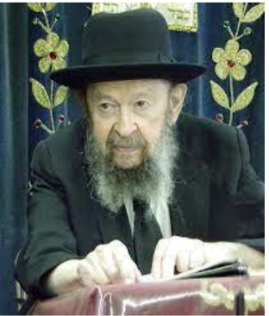

On all sides you could see nissim and niflaos in nature. On all sides Hakadosh Baruch Hu has left simanim to recognize His handiwork, His plan and purpose in the world. I was walking today with a young man, and we saw a peach pit lying on the sidewalk. I said, “Look at that, a miracle!” He said, “What? It’s a peach pit.”

No, it’s proclaiming its Creator. First-of-all there's nothing in the peach tree as hard as a peach pit. It's the hardest material in the whole thing because it’s purpose to protect the seed. It’s a remarkable material; lignin and cellulose, the same tough substances that make up wood and bark.

Also, it’s composed of two halves that fit together exactly. But try to pull them apart; in most cases you'll fail. You can't do it. Because they’re pasted together with a cement; a special formula that’s extremely strong. But if you take the peach pit and put it inside the ground and it opens up by itself! Because that cement-material yields to the bacteria and the fungi in the soil.

So, here's the peach pit with the two halves exactly fitted together with a cement that resists your efforts to pull it apart, and still when it’s in the soil it cracks open by itself. Eventually, moisture seeps in, and the embryo inside swells, builds pressure, and cracks the pit open from the inside. And now the seed is ready to begin producing another peach tree. So here you see now it’s not just a peach pit. It’s a message from Hakadosh Baruch Hu. You can’t just walk by and ignore it. Stop and look at it. Hakadosh Baruch Hu is talking to you: “I'm giving you another opportunity to gain emunah,” He says.

*Reprinted from the current Devorim 5785 email of Torah Avigdor.*

**The Three Distinct**

**Aspects of G-d’s Unity**

**From the Teachings of the Lubavitcher Rebbe**

**Rabbi Menachem Mendel Schneerson, Zt”l**

This week's Torah portion, Vaetchanan, contains the verse, "And you shall know this day, and take it to heart, that the L-rd is the G-d in the heavens above, and upon the earth below; there is none else." This recognition of G-d's unity may be divided into three distinct areas: "heaven," "earth," and "there is none else" (which, according to the Midrash, refers to G-d's oneness "even within the very depths of the earth."

Why does the Torah go to such great lengths to emphasize the oneness of G-d? Would anyone seriously entertain the notion that there is another G-d hiding in the murky depths of the sea or in the earth's core? Why is it necessary for the Torah to explicitly command us to "take it to heart?"

Chasidic philosophy explains that this verse not only negates the possibility of another deity's existence, G-d forbid, but rather emphasizes the fact that there is no existence at all besides G-d. G-dliness is the only reality; everything else is an illusion covering up the true essence within. Were we able to clearly perceive that there is no independent reality except for G-d, we would easily recognize that it is only G-d's constant re-creation of the world, every minute and every second, that sustains both physical and spiritual reality. In truth, "there is nothing else."

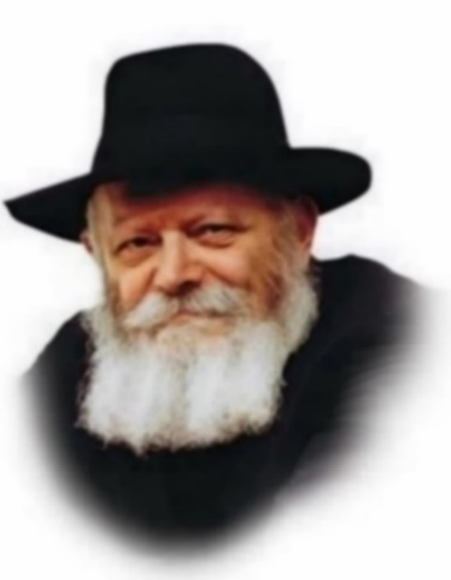

Because one may mistakenly think that only spiritual matters are G-dly, the Torah specifically mentions "the earth below." The physical world, with its multitude of creations, is also a vessel for G-dliness, and must be properly utilized in the service of G-d.

This division is also symbolic of man himself: "Heaven" refers to man's G-dly soul; "earth" refers to his corporeal body, the vessel in which the G-dly soul illuminates; and "the very depths of the earth" refers to man's actions.

By stressing this verse, the Torah emphasizes that this awareness of G-d must be brought into all facets of our lives - spiritual, physical and practical. By recognizing G-d's unity and reflecting it in our every action, we ready the entire world for the complete revelation of G-dliness that will take place with the coming of Moshiach and the Final Redemption, speedily in our days.

*Reprinted from the Parshat Va’etchanan 5762/2002 edition of L’Chaim, a publication of the Lubavitch Youth Organization in Brooklyn, NY. Adapted from the works of the Lubavitcher Rebbe.*

**Tattooed Together**

**in Auschwitz**

**By Sofya Tamarkin**

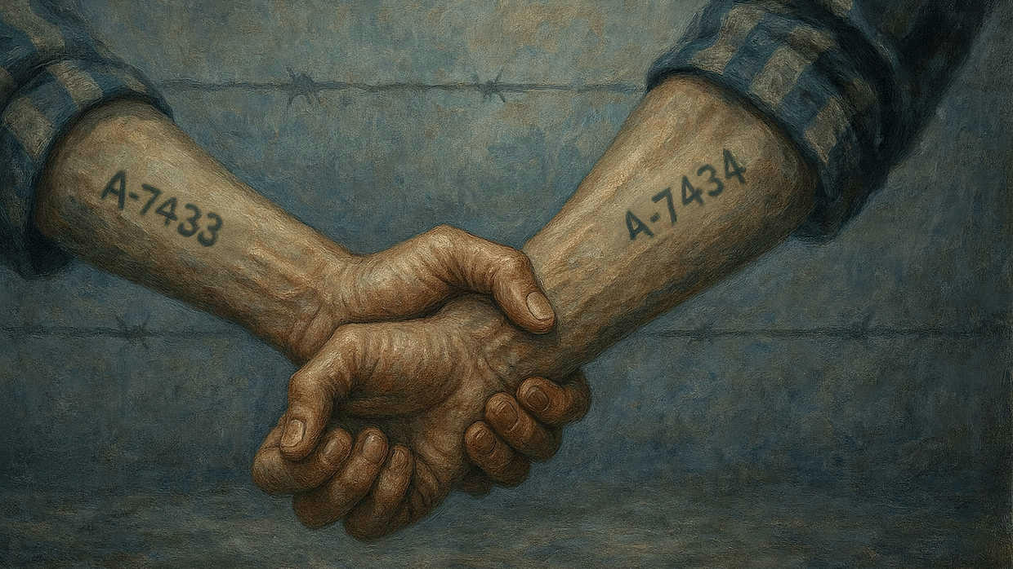

*Two brothers clung to faith, hope, and each other—through ghettos, death marches, and decades of separation.*

Everyone loved Reb Moshe Shenberger, a quiet, elderly man with kind, wise eyes and a warm, vibrant smile that lit up the synagogue. Children ran to him for candies, unaware of the number tattooed on his arm: A-7433. That number, silently etched into his skin, held the story of an unimaginable past—one of survival, faith, and a bond with his brother Ellie that defied death itself.

Born Morris Shenberger in 1924, on the eve of Passover, he grew up in Sychi, a small shtetl in Subcarpathian Czechoslovakia. The Shenberger family—devout, hardworking farmers—had nine children. Morris was especially close with his younger brother Ellie, born two years after him. Their lives revolved around faith, family, and tradition.

In 1939, their mother passed away from kidney failure and children were left with more responsibilities. Soon after more troubles came their way, the region was occupied by Hungary, then an ally of Nazi Germany. Jewish life became increasingly restricted. Jews had to register with the police and were required to carry special permits. Morris remembered local police entering Jewish homes and publicly beating his father, cutting off his beard in front of the family. “The shock of that incident,” he later said, “stayed with me for the rest of my life.”

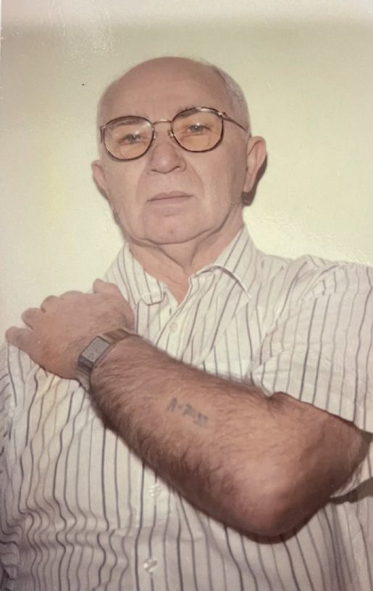

***Morris with his tattooed number after arriving in the United States***

In 1942, Hungarian soldiers confiscated their livestock. With their horse gone, Morris and Ellie hauled firewood by hand at 2 a.m. to earn food for the family. Later, when Jews were forced to wear yellow stars, Morris stood in line at the store only to be yelled at: “Get out of the line, Jew!” Often, he returned home empty-handed.

In 1944, the Hungarian Nazis gave the family 30 minutes to pack. They were deported to the Uzhgorod ghetto—an open yard with no shelter, no roof, and no protection from snow, wind, or rain. Their father had managed to bring a kerosene stove and a water bucket—items that saved their lives. They stayed in that square for three weeks.

Then the Nazis announced a transfer to a “better place” and ordered them to leave everything behind. The destination was Auschwitz-Birkenau.

Morris recalled the horror: children crying, people crammed into cattle cars, and the suffocating ride into the unknown. When they arrived, he was immediately separated from his family. “I asked a prisoner where they were,” he remembered. “He pointed to the smoke coming from a chimney and said, ‘That’s your family.’ I cried all night until I heard loud banging—a signal to line up."

**Tattooed Together**

In a moment of miracle, Morris spotted his brother Ellie in another group. Taking advantage of the distraction, the boys managed to switch places with other prisoners and were reunited. They were tattooed together—A-7433 and A-7434—and remained side by side through every torment that followed.

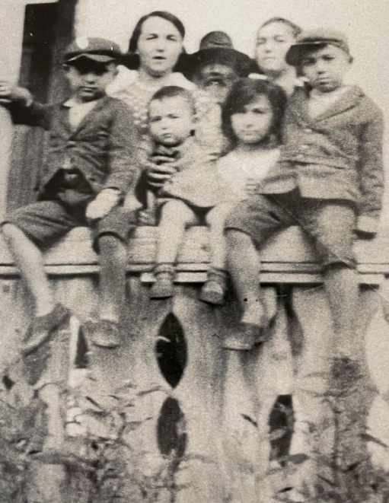

***The family before the war. Morris on the***

***bottom right, his brother Ellie first on the***

They found strength in each other. At night, lying on wooden planks, they counted blessings: an extra crust of bread, a glimpse of sun, a few berries on the roadside. They reminded each other to keep going.

**Death March**

In January 1945, as Soviet forces advanced, the brothers endured a brutal Death March to Buchenwald. Morris remembers, "All night we walked on foot, then all day, and another night without stopping, and another day. On the third night, we approached a railway station in Buchenwald. My leg was wounded, and I could barely step on it. I survived because I was leaning on Ellie, who himself was barely standing on his feet from exhaustion. Through the entire journey, Ellie held our bread and put pieces of it in my mouth to give me strength."

Loaded into open rail wagons filled with snow, they knew they wouldn’t survive sitting still.

"Ellie whispered to me that he could no longer feel his legs. I felt the same. Together we devised a plan. We carefully shifted to move even closer and began massaging each other’s legs, keeping circulation going. We did that for 12 hours straight while the train was moving. That’s what saved us both. My brother and I—we looked out for each other."

Forty-five people in their wagon froze to death.

After surviving Buchenwald and a month in the underground tunnels of Ohrdruf, they were transported to Theresienstadt. On the seventh day, the train stopped. They feared more Nazis—but it was the International Red Cross. Morris collapsed, unconscious from typhus. Ellie refused to leave him, sitting by his hospital bed, crying:

“Please don’t give up now—after all we’ve been through. Please fight for your life.”

**Separated for 31 Years**

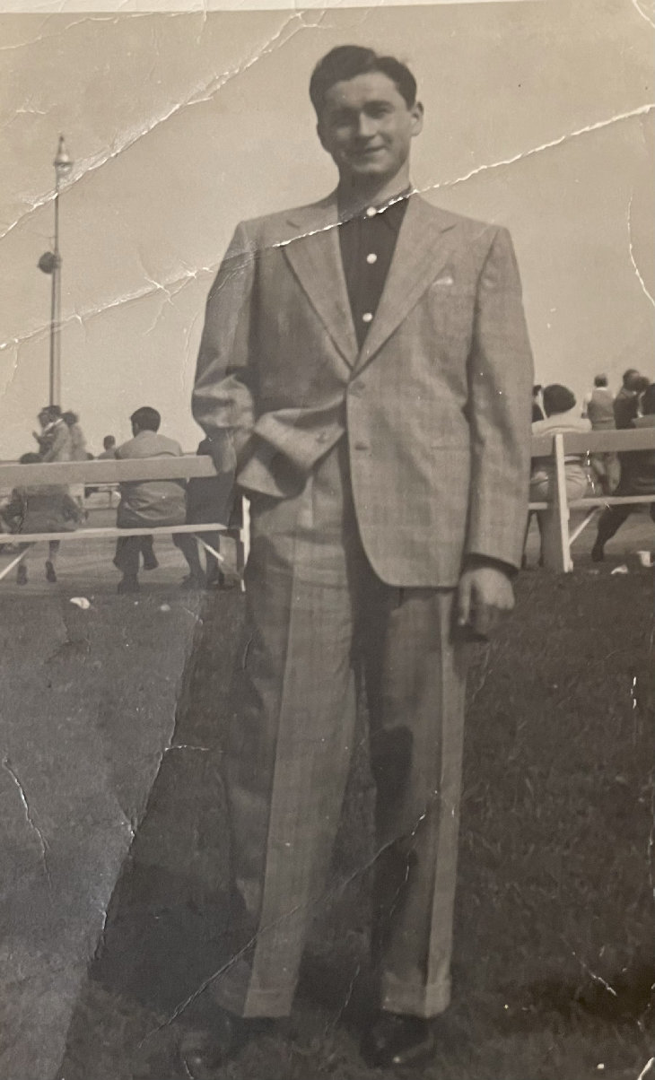

***Ellie as a young man after the war***

But Ellie was sent to England. For the first time since they vowed never to be separated, Morris had to stay behind to recover. Their parting—meant to be temporary—lasted 31 years.

Morris eventually regained strength and returned to Uzhhorod, Ukraine. There, he learned that five of his siblings had survived. He never saw his father again.

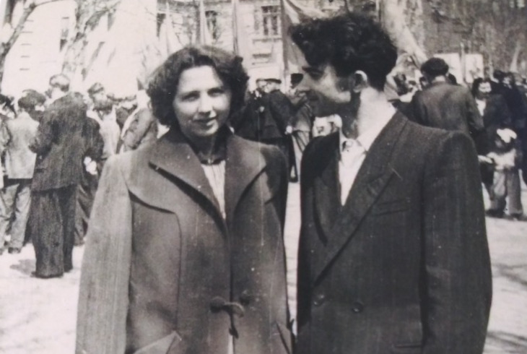

***Morris with his young wife in Ukraine in 1954***

Despite enduring unspeakable horrors, Morris remained gentle. He cherished simple things: nature, a soft bed, warm clothes, Jewish holidays, family gatherings, and quiet gratitude. He never lost his faith in G-d. He never became bitter.

Ellie, believing they’d soon be reunited, sent packages and letters. But Morris remained behind the Iron Curtain. Only in 1976, when Morris immigrated to the United States with his family, did the brothers finally embrace again.

When they finally held each other, there were no words to describe the depth of their emotions.

Both brothers built beautiful families.

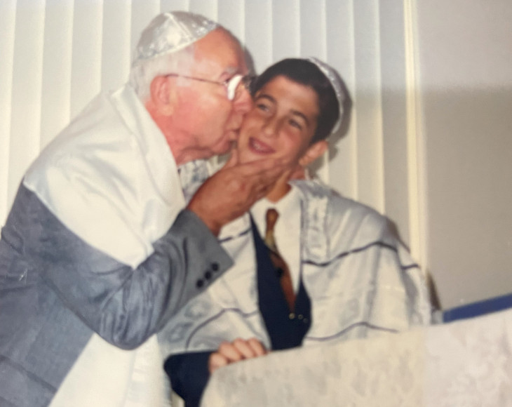

***Morris at the Bar Mitzvah of his grandson***

Morris became a tailor. He married Eve and had two daughters, four grandchildren, and four great-grandchildren. He passed away in 2015.

Ellie became a restaurant owner. He married Francis, had two daughters, and passed away in 1986, leaving behind grandchildren and great-grandchildren.

Their love, loyalty, and shared resilience helped them survive the unimaginable. Through it all, they kept each other alive.

Their story reminds us of a timeless truth: We are our brother’s keepers.

*May the memories of Moshe ben Avraham and Ellie ben Avraham, and all those who perished in the Holocaust, be a blessing.*

***Reprinted from the current website of aish.com***

**Thoughts that Count**

**for Our Parsha**

*And I besought G-d at that time, saying... "Let me go over, I pray You, that I may see the good land*" (Deut. 3:23-25)

The Midrash relates that Moses beseeched G-d with 515 prayers (the numerical equivalent of the word "va'etchanan" - "and I besought") to be allowed to enter the Land of Israel. Even after G-d explicitly told him, "Do not continue to speak to Me any more of this matter," Moses persisted. We learn from this that we must never give up begging and imploring G-d to allow us back into the Land of Israel, with the coming of Moshiach, for we have been promised that we are the last generation of exile and the first generation of Redemption. *(The Lubavitcher Rebbe Shabbat Parshat Devarim, 5751)*

Why did Moses so desire to enter the land? "The Jewish people have been commanded many mitzvot (commandments) which can only be done in the Land of Israel. Let me therefore enter the land so that they can all be performed through me," he reasoned, as related in the Talmud. Moses' motivation was not personal. Rather, had Moses merited to accompany the Jewish people into Israel, the Final Redemption would have occurred immediately, without the necessity of having to endure subsequent exiles and wait several thousand more years for Moshiach. *(The Rebbe, 5746)*

*Take good care of your souls* (Deut. 4:15)

One must not abuse or neglect the physical body, for "a small defect in the body creates a large defect in the soul." *(The Mezeritcher Magid)*

*From there you will seek the L-rd your G-d and will find Him* (Deuteronomy 4:29)

It is precisely when you seek the L-rd your G-d "from there" - from the depths of your heart and with a sense of complete nullification before the Creator, that "you shall find" the sudden revelation of the greatest G-dly light. *(The Baal Shem Tov)*

*You have been shown to know that the L-rd is G-d* (Deuteronomy 4:35)

When G-d revealed Himself on Mount Sinai to the soul of every Jew of every generation, He thereby made it possible for any Jew who sincerely desires to serve Him to perceive the true essence of the world, despite the darkness and concealment of what presents itself as reality. *(Sefat Emet)*

*Reprinted from the Vaetchanan 5762/2002 edition of L’Chaim.*

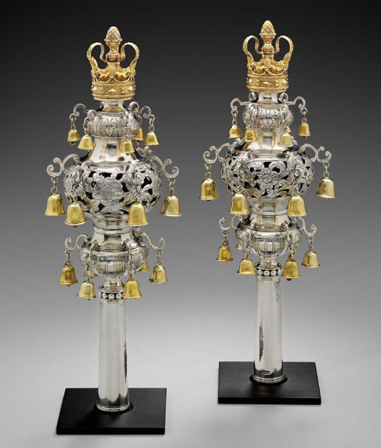

***18th Century Torah Finials from the Touro Synagogue in Newport, Rhode Island by Myer Myers which is now on display in the Museum of Fine Arts in Boston, Mass****.*